Stem-and-Leaf Display: Program
Stem-and-leaf of Program N = 30
Leaf Unit = 0.10

1 0 0
1 0
3 1 00
3 1
4 2 0
5 2 5
7 3 00
8 3 7
15 4 0000000
15 4
- 5 0000000000000001
- The lowest parkng price is $0.0
- To add an observation of $5.16, add an additional “1” to the leaf column of the stem unit 5.
- Most leaves have the value of 0 because most programs are whole number prices to make cash exchange easier.
- Toronto has a leaf value other than 0 or a6 because Toronto is outside the U.S. and the price must be converted from Canadian dollars to U.S. Dollars.
- The distribution is mostly symmetric unimodal wiath an outlier.
- In a stemplot you can see a count of individual values rather than just ranges of values.
- The increase in bin value shows smaller ranges, which changes the overall shape of the graph and can lend to different interpretations of the data. The stemplot provides a more accurate representation of the data because it displays individual values.
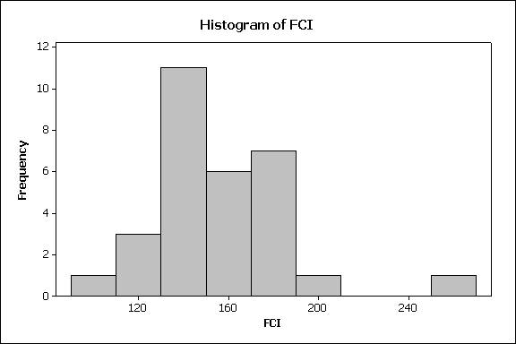

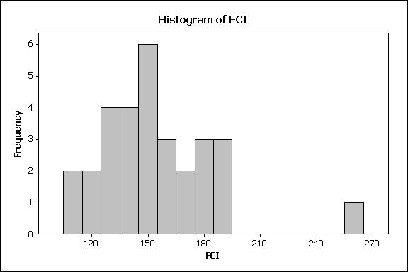

Mean of FCI = 155.480 $μ$
Median of FCI = 151.13 $\tilde{μ}$

- These are population values.
- The mean and median values are similar because the distribution is relatively symetric.

Dotplot of Diff
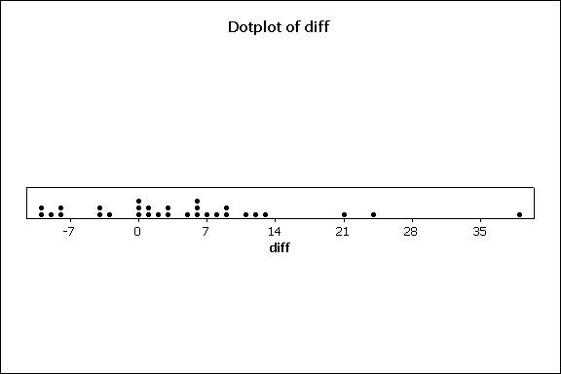
10. Values to the left of 0 show a decrease in FCI. The proportion, p is 8/30 or .267.
Descriptive Statistics: diff
Variable N N* Mean SE Mean StDev Minimum Q1 Median Q3 Maximum
diff 30 0 4.39 1.95 10.67 -10.01 -2.91 3.09 8.64 39.05

11. Q1 represents the mean of the lower half of the data. This value was -2.91 meaning on average, there was a decrease in the lower half of the data of 2.91.
12. This variable is split almost equally in positive and negative values, with the exception of a few outliers, as seen on the dotplot. The data is relatively symetric around the center (3.09). The center and average values are fairly close, signifying sysmetry. The mean is affected by the outliers, so the median would be a more accurate representation of the data.
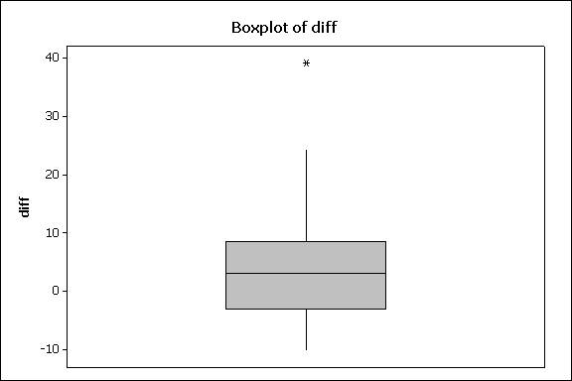

13. The boxplot of the MLB data shows 2boxes, one for those teams that raised their ticket prices from the previous year and one for those which have lowered ticket prices. This view is limited in that it does not show the distribution of price decreases/increases or the shape of the data varaience.
14. Philidelphia is the outlier in this dataset.
15.
f_{s} = Q3 – Q1 = 8.64 - -2.91 = 8.94 + 2.91 = 11.85
1.5 * 11.85 = 17.77
16. Calculating a percentage change is more informative because it can be significantly compared to other values. Simply comparing differences is not as conclusive because not all values were the same to begin with.
17.
Descriptive Statistics: % change
Variable N N* Mean SE Mean StDev Minimum Q1 Median Q3 Maximum
% change 30 0 2.91 1.25 6.86 -6.48 -1.76 2.00 7.21 26.16

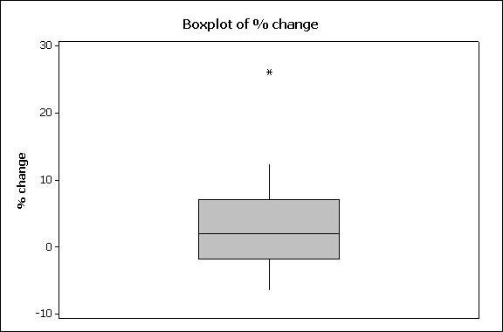
The outlier, Philidelphia, is the same as before.

Descriptive Statistics: % change (after deletion of Philadelphia)

Variable N N* Mean SE Mean StDev Minimum Q1 Median Q3
% change 29 0 2.112 0.997 5.367 -6.477 -2.037 1.855 6.396

18. The mean increased much more than the median decreased because the outlier, with its extreme value, has more effect on the mean than the median.
19. Both decreased because the extreme value of the outlier didn’t obscure the calculation of the values. Because the outlier was eliminated, the values were “closer” together on a whole, so the StDev decreased.

Descriptive Statistics: UCI

Variable N N* Mean SE Mean StDev Minimum Q1 Median Q3 Maximum
UCI 29 0 89.25 3.30 17.78 62.56 76.82 85.82 100.93 154.04

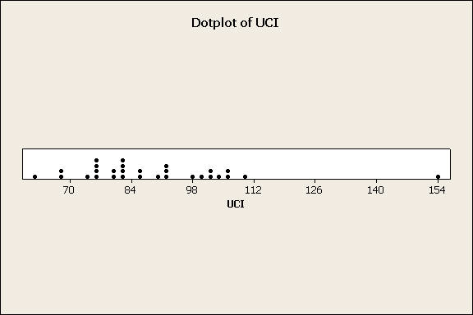

20. The UCI is the cost of our group’s expenses including two avg. tickets, two sodas, two hot dogs, and one parking ticket. The variable’s dataset is relatively symmetric, and the mean and median are close in value, the mean being greater due to the high outlier. A dot plot of the data suggests that the spread is relatively even with the exception of an outlier. The data is more accurately represented by the median because of this outlier. The data is more centered on higher values in the 70s and lower values in the 80s.
21. Florida offers the best deal with 62.56, while Boston offers the most expensive deal, 154.04.
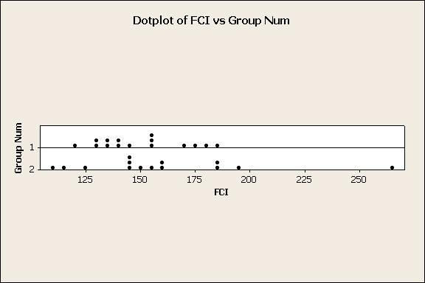

Descriptive Statistics: FCI

Group
Variable Num N N* Mean SE Mean StDev Minimum Q1 Median Q3 Maximum
FCI 1 15 0 149.57 5.02 19.44 120.68 132.92 145.96 170.44 184.90
2 14 0 159.5 10.4 39.0 108.8 138.7 152.9 183.6 263.1

22. The five number summary for the FCI of group 1 (West of the Mississippi River) is: 120.68 132.92 145.96 170.44 184.90

The five number summary for the FCI of group 2 (East of the Mississippi River) is:
108.8 138.7 152.9 183.6 263.1

23. Both groups are relatively symmetrical. Group 2, the east coast teams, are more varying with a StDev of almost 20 greater than that of Group 1. Although group 2 has an outlier, the values still appear more deviant from the mean on the dot plot. Group 1’s values are more centered around the median value. Also, Group 2 seems to tend to higher values than Goup 1. The dots on the graph for Group 2 tend to the right more than Group 1. Overall, Group 2 will be more expensive than Group 1.

