Lab 2: Random Babies!

Class Experiment and Java Simulation

From the index card simulation, the class discovered that the possible outcomes of matches were 0, 1, 2, and 4, but not 3. If three babies match, then the remaining must also match because the only mother left is the correct one. One match was the most frequent. The data from the class is shown below. The proportion of at least one mother receiving the correct baby was .66

# of matches | 0 | 1 | 2 | 3 | 4 | Total
Count | 49 | 60 | 34 | 0 | 7 | 150
Proportion | .33 | .4 | .227 | 0.00 | .047 | 1.00
Through the Java applet, we were able to get a more accurate estimations. The results are shown below. This shows that zero number of matches is the most likely, rather than 1, the most unlikely being 4. Recalculating, the probability of at least one correct match is .606. The data shown by the dotplot indicates the average number of matches is 1.012. As the number of trials increases, the average number of matches settles on a value. A second Java experiment was run using 1000 trials. This showed that the values continue to settle with more increasing trials. The values for 0 matches for 500 trails was .394. The frequency of 0 matches for 1000 trials was 3.78. The graph shows that the value has settled fairly well on one value. For 1000 trials the average matches settles around 1.0006. The values of the graph cluster around approximately 1. With even more trials the value could change, but 1.0006 is a very close estimate.

# of matches | 0 | 1 | 2 | 3 | 4 | Total
Count | 197 | 154 | 126 | 0 | 23 | 500
Proportion | .394 | .308 | .252 | 0.00 | .046 | 1.00

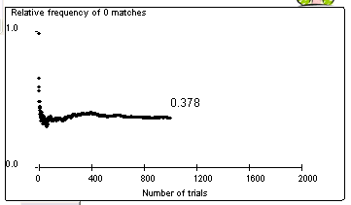
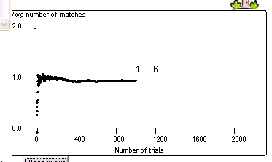

Calculations for exact probabilities:

There were two ways to calculate the exact number of permutations. One way was writing out the entire sample space and counting the permutations. The other way was performing the product 4 * 3 * 2 * 1 = 24, or 4!.

Using the written out sample space, it was easy to find probabilities for an event by counting the number of outcomes that resulted in the event and dividing by the total outcomes of S, 24. For an event A, the probability, P(A) = # of outcomes in A / # of outcomes in S. The table below shows the # of outcomes for an event and the calculated probability.
# of matches | 0 | 1 | 2 | 3 | 4
Outcomes | 9 | 8 | 6 | 0 | 1
Probability | .375 | .333 | .25 | 0.00 | .0417

For the probability of at least one mother receiving the correct baby, they are two ways to calculate it. One way is P(at least one) = P(1) + P(2) + P(3) + P(4). The other way is the complement of the first way, or P(at least one) = 1 - P(0) = .625.

The expected value for the number of matches can be calculated by the summation of each # of matches multiplied by its probability. This is 1/3 + 2/4 + 1/6 = 1. Compared to the simulation value, it is fairly close. (1.006 vs. 1.0). The expected value for the number of babies is different from the most probable outcome. The expected value is an average value, and the most probable outcome (0), is the event most likely to happen.

Analysis of 8 Cell Phones:

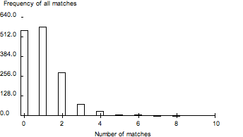

We are convinced enough trials were run because the Avg Number of Matches converges to the number .97 and is stable at the end of the trial. While 8 should be possible, there was no runs which produced an 8, while 7 is impossible. All the other values, 0-6 were encountered in the trials. See the Table for associated relative frequencies. The histogram, as you can see, is positively skewed, with a center around 1 and a spread from 0 to 6. 8 is possible but least likely. The probability of at least one match is around .632. The Avg number of matches is .97.

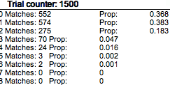

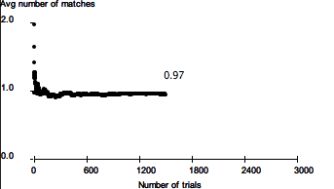

Exact analysis shows that the sample space includes 8! = 40320 possible outcomes. This is not a feasible number of outcomes to list as was with 4 babies. The exact probability of all 8 cell phones being picked up by their proper owners is 1 / 40320 = .000025. The probability of less than 8 people picking up their own cell phone is the complement of the previous value, or .999975.

